Outstanding Advances
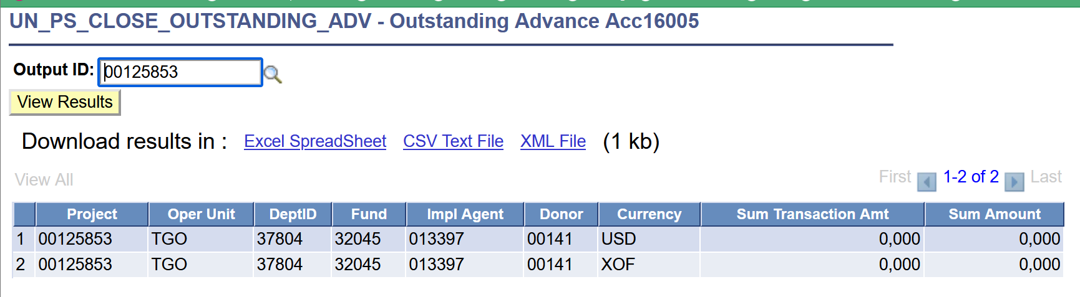
Outstanding Advances Other
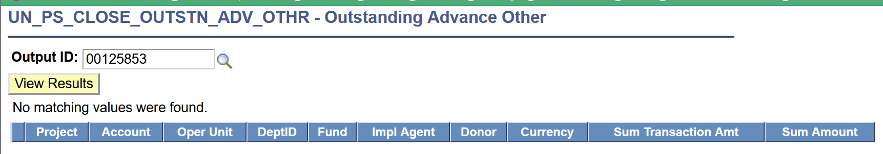
No outstanding Project Delivery Reports (PDRs);
Non applicable
Open Purchase Orders
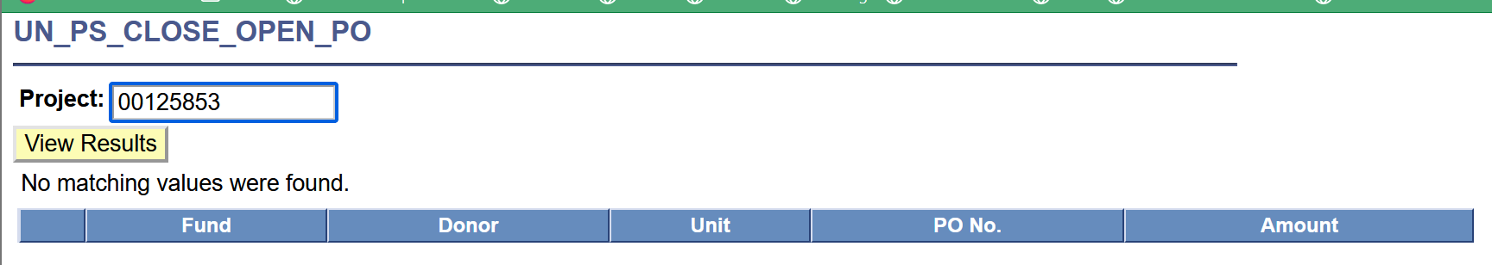
Receipt Accruals
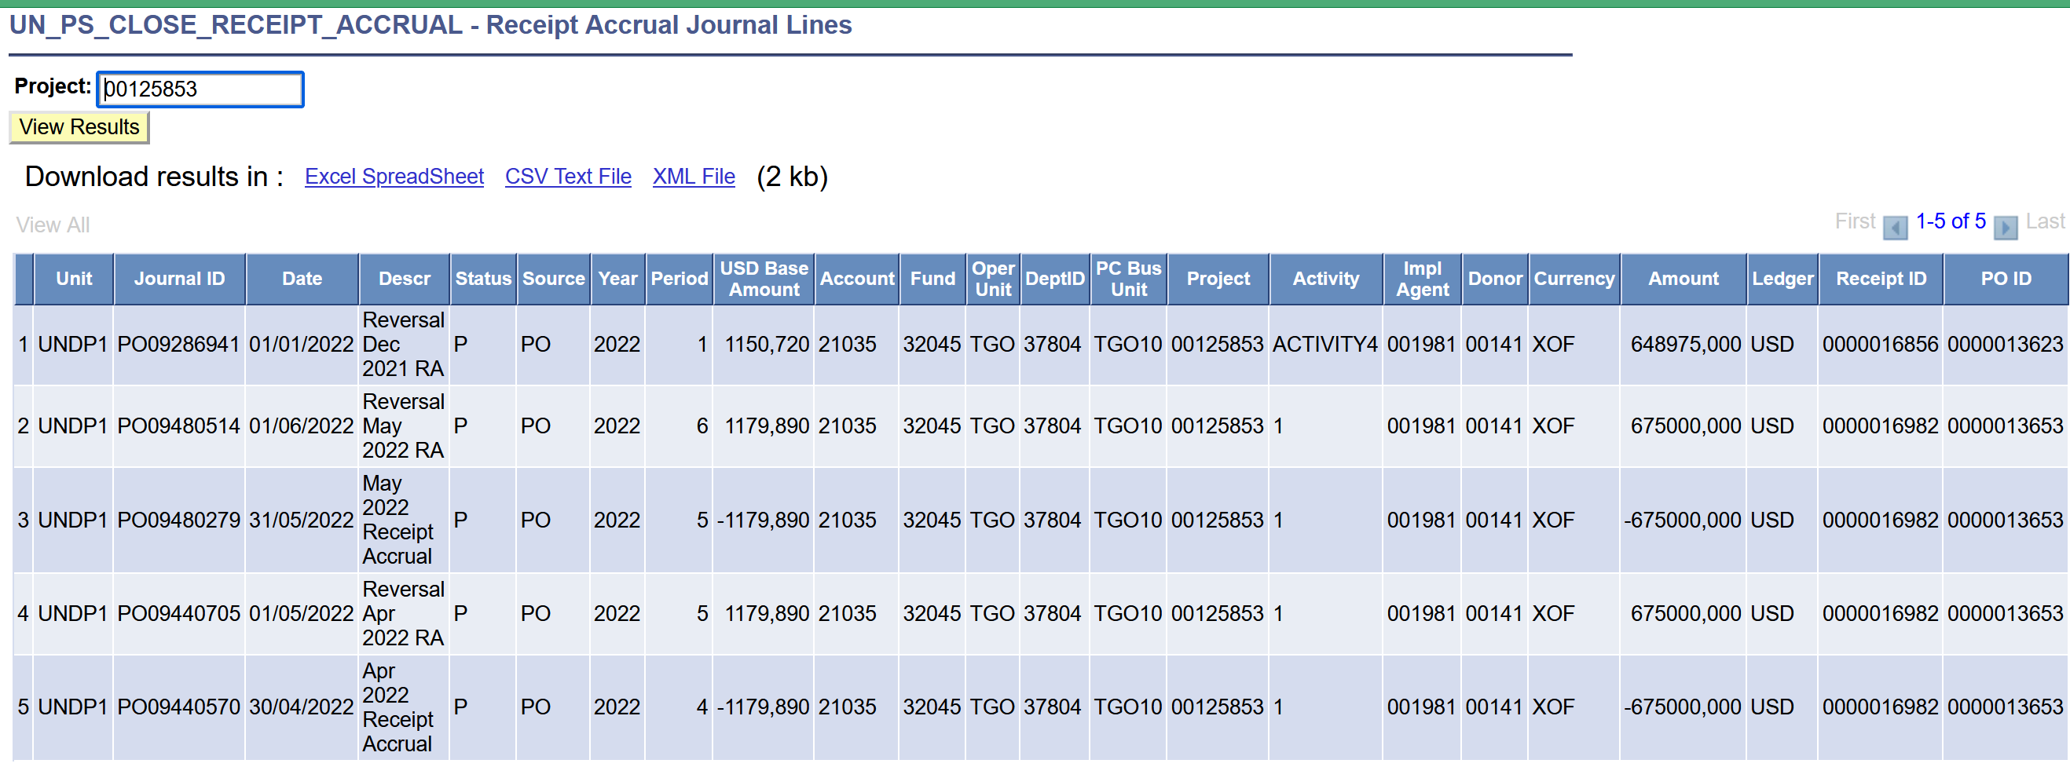
No Outstanding Commitments
Aucun PO ouvert sur le projet
Prepaid Vouchers
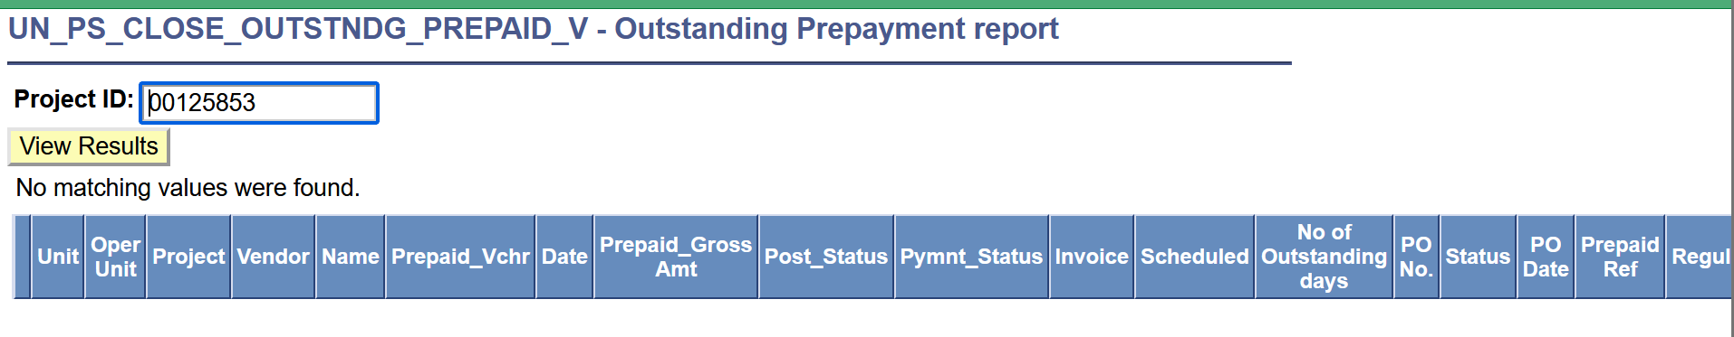
No Pending Vouchers
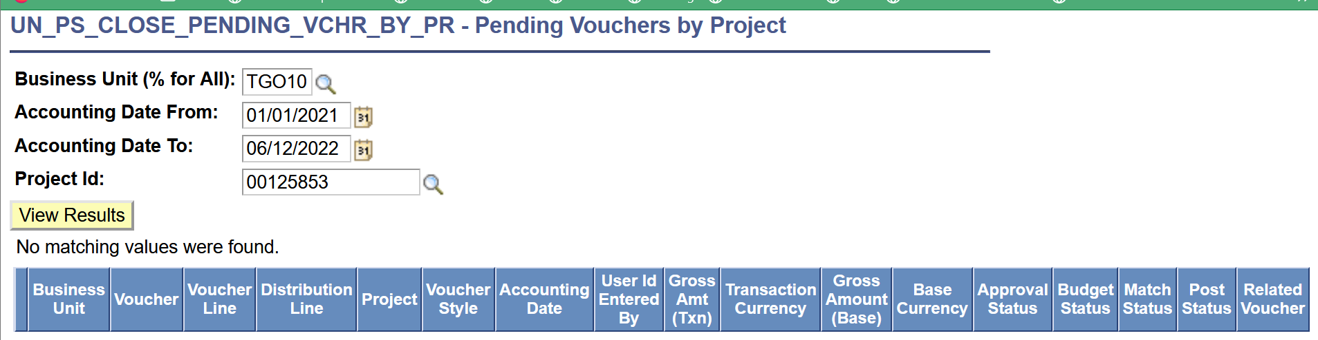
All pre-financing activities have been recovered and/or reimbursed.
Non applicable
Charged GMS Rate %
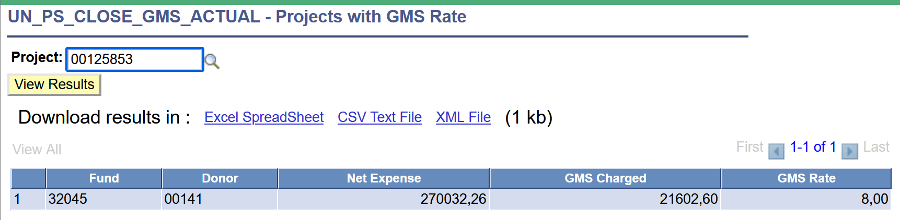
GLJEs Not Posted
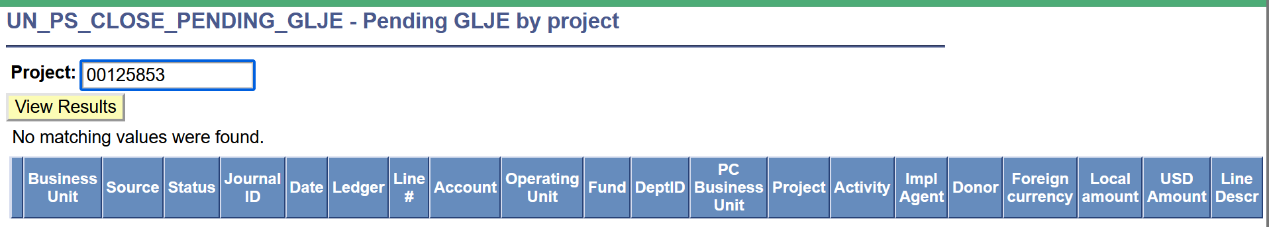
Unapplied Deposits by Office
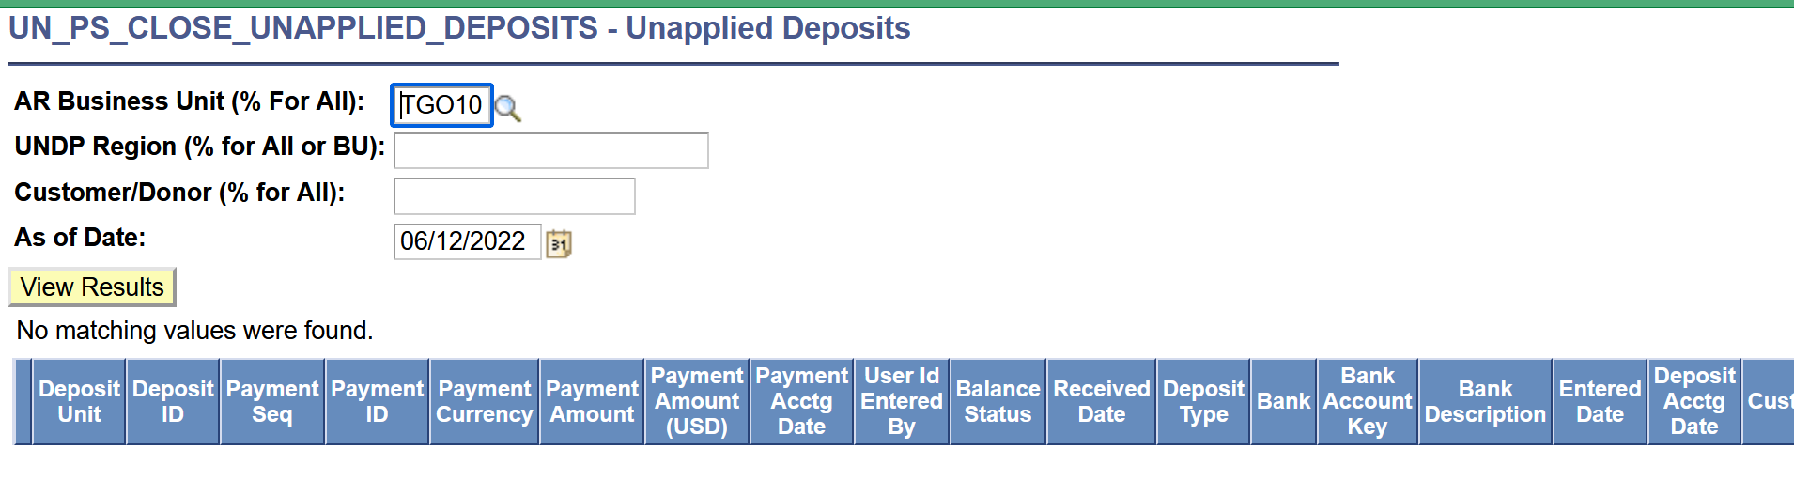
Contract Pending Events
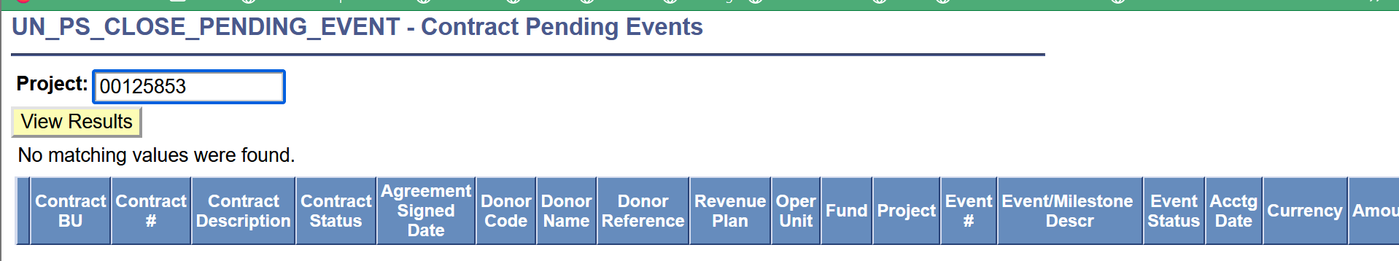
Contribution Amount Not Collected
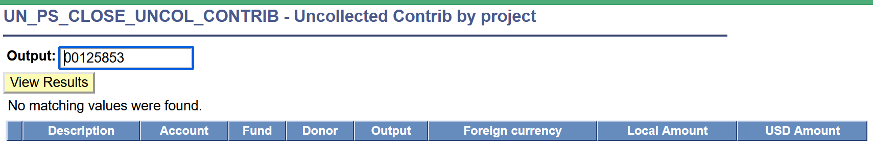
No Pending AR direct journals
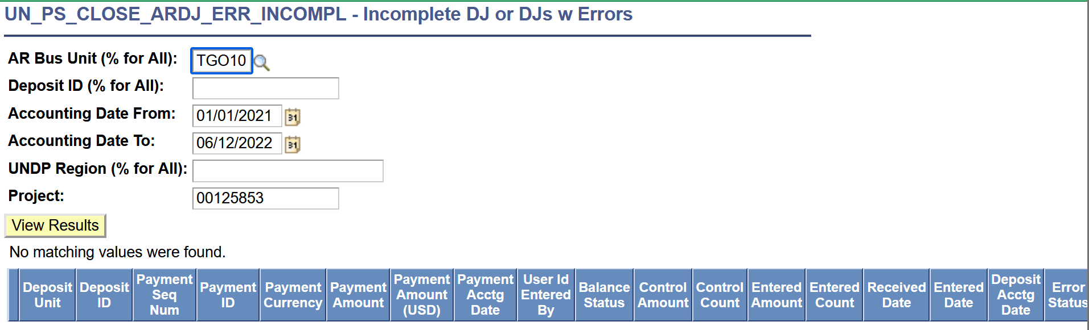
Assets
Voir fichier assets
Petty Cash & Cash Advance
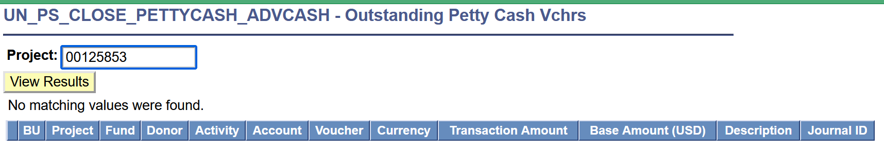
Staff Receivables
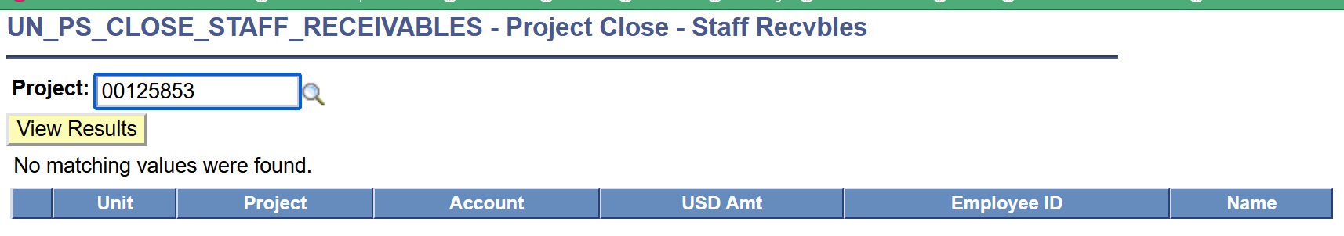

Employee Benefits
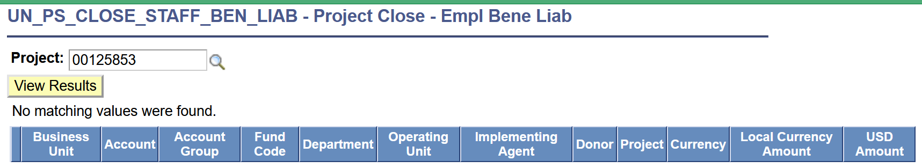
Pending Liabilities
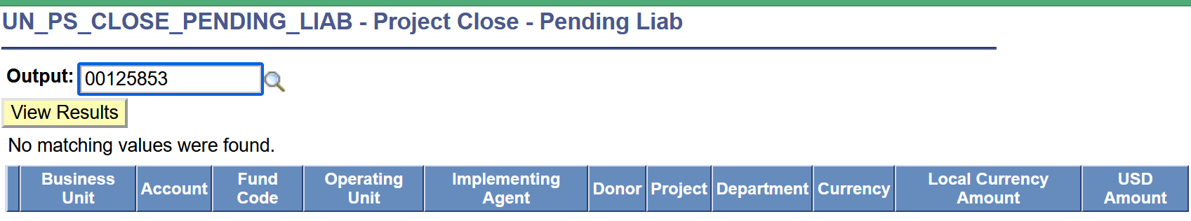
The CDR for the previous quarter shows Zero future expenses (commitments).
CDR uploader sur Atlas
Final LPAC / Steering committee minutes are available.
Rapport final du comité de pilotage disponible
All audit observations are closed with supporting documentation.
Non applicable
The final CDR is signed by UNDP and the Implementing Partner. Final report submitted by responsible parties.
Non applicable
If cost sharing project, the unexpended balance has been agreed to the general ledger. (The Balances excludes Open Purchase Orders reflected in the Output Financials) AND (Excludes Outstanding Contribution Receivable to be collected from donor) if any.
Non applicable
Consultations with Donors on the disposition of unexpended cost-sharing balances, where required by contribution agreement, have taken place and are documented in writing.
Les consultations ont eu lieu et le japon a été informé que le reliquat sera reversé
All refunds to donors have been transferred to Account 21030 (Pending Refund to Donors) and the project Balance is Zero. (Only in Base Currency)
Processus en cours
Notified Treasury Contributions Unit if the donor agreement requires interest to be refunded to the donor if specified in the agreement.
Non applicable
Notified the GSSC to close any associated contract in the contracts module.
Non applicable
All donor reports, as established in the Cost Sharing agreement, were submitted and acknowledged receipt by the donor representative.
Tous les rapports ont été soumis avec accusé de réception
Ensure project accounts are closed.
Une action sera prise si nécessaire dans le cadre de ce projet

